ECON 101 – MACROECOMICS
Final Exam
EXAMINER: MUHEBULLAH KARIMZADA
December 09, 2025

Instructions:
1. You have 120 minutes to work on the exam.
2. This exam is individual and closed-book.
3. For the multiple-choice questions, choose the option that best answers/completes the question.
4. This Examination paper includes 17 pages (includes the cover page). You are responsible for ensuring that your copy of the paper is complete. Bring any discrepancy to the attentions of your invigilator.

PLEASE: PUT YOUR NAME AND STUDENT ID ON EVERY SHEET!!

Multiple Choice Answers:

1. _________ 17. _________ 33. _________ 49. _________ 65. _________

2. _________ 18. _________ 34. _________ 50. _________ 66. _________

3. _________ 19. _________ 35. _________ 51. _________ 67. _________

4. _________ 20. _________ 36. _________ 52. _________ 68. _________

5. _________ 21. _________ 37. _________ 53. _________ 69. _________

6. _________ 22. _________ 38. _________ 54. _________ 70. _________

7. _________ 23. _________ 39. _________ 55. _________ 71. _________

8. _________ 24. _________ 40. _________ 56. _________ 72. _________

9. _________ 25. _________ 41. _________ 57. _________ 73. _________

10. _________ 26. _________ 42. _________ 58. _________ 74. _________

11. _________ 27. _________ 43. _________ 59. _________ 75. _________

12. _________ 28. _________ 44. _________ 60. _________ 76. _________

13. _________ 29. _________ 45. _________ 61. _________ 77. _________

14. _________ 30. _________ 46. _________ 62. _________. 78. _________

15. _________ 31. _________ 47. _________ 63. _________ 79. _________

16. _________ 32. _________ 48. _________ 64. _________ 80. _________
MULTIPLE CHOICE. Choose the one alternative that best completes the statement or answers the question.

1) The response of investment spending to an increase in the government budget deficit is called
A) expansionary investment.
B) crowding out.
C) private dissaving.
D) income minus net taxes.
E) accelerating investment.

2) A decrease in which of the following would decrease the tax wedge?
A) marginal tax rate
B) national debt
C) money supply
D) federal budget deficit
E) property taxes

3) The largest component of spending in GDP is
A) wages.
B) government spending.
C) investment spending.
D) net export spending.
E) household spending.

4) In the long run,
A) the inflation rate is zero.
B) unemployment is at its natural rate.
C) GDP > potential GDP.
D) LRAS and SRAS lie on the same line.
E) the aggregate demand curve becomes flat.

5) In preparing their estimates of the economic impact of a new football stadium in the City of Regina, proponents argued that building the stadium would create twice as much economic activity in the city as the stadium was projected to cost (essentially arguing that the local multiplier was 2). This is likely to be an overestimate of the multiplier because
A) construction projects generate no additional economic activity.
B) Regina's marginal propensity to consume is too great.
C) imports and income taxes will reduce the impact of new spending.
D) the price level in the local economy is likely to be insensitive to a major construction project.
E) the marginal propensity to save in Saskatchewan is much higher than in other parts of the country.

6) The Bank of Canada uses ________ to measure inflation.
A) the producer price index
B) the index of leading economic indicators
C) the GDP deflator
D) the consumer price index
E) the personal consumption expenditures index

7) Examples of assets that are included in household wealth would be
A) stocks, bonds, and household appliances.
B) stocks, bonds, and mortgages.
C) stocks, credit cards, and savings accounts.
D) stocks, bonds, and savings accounts.
E) stocks, loans owed, and savings accounts.

8) Using the quantity equation, if the velocity of money grows at 5 percent, the money supply grows at 10 percent, and real GDP grows at 4 percent, then the inflation rate will be
A) 19 percent.
B) 15 percent.
C) 6 percent.
D) 14 percent.
E) 11 percent.

9) The purchase of a new house is included in
A) consumption expenditures.
B) imports.
C) government purchases.
D) investment expenditures.
E) exports.

Table 4.20
 | 2018 |  | 2020
Product | Quantity | Price | Quantity | Price
Cameras | 100 | $10 | 120 | $12
Legal services | 50 | 15 | 45 | 20
Books | 200 | 40 | 210 | 45

A very simple economy produces three goods: cameras, legal services, and books. The quantities produced and their corresponding prices for 2018 and 2020 are shown in the table above.

10) Refer to Table 4.20. What is real GDP in 2020, using 2020 as the base year?
A) $28,885
B) $11,790
C) $11,200
D) $10,275
E) $8,750

Table 4.21
 | 2019 | 2020
Nominal GDP | $10,000 | $12,000
Real GDP | 9,500 | 10,500

11) Refer to Table 4.21. Given the information above, calculate the GDP deflator in 2019.
A) 87
B) 95
C) 100
D) 105
E) 114

12) A monetary growth rule means that
A) the Bank of Canada will raise interest rates if it thinks the economy is growing faster than potential.
B) the Bank of Canada will lower interest rates if it thinks a recession is on the horizon.
C) the money supply should grow at the same rate as the population.
D) the money supply should grow at a constant rate.
E) the money supply should grow in response to economic conditions.

13) A government tax rebate of $1,000 would ________ your disposable income by ________.
A) decrease; less than $1,000
B) increase; $1,000
C) increase; less than $1,000
D) increase; $500
E) decrease; $1,000

14) Which of the following is an objective of fiscal policy?
A) energy independence from Middle East oil
B) winning hockey gold at the winter Olympics
C) drug plan coverage for all Canadians
D) discovering a cure for AIDs
E) high rates of economic growth

15) The aggregate demand curve will shift to the right ________ the initial decrease in taxes.
A) by less than
B) by more than
C) by the same amount
D) sometimes by more than and other times by less than
E) None of the above.

Table 10.3
Assets | Liabilities
Reserves +$7,000 | Deposits +$50,000
Loans +$46,000 | Net Worth +$3,000
16) Refer to Table 10.3. Consider the following simplified balance sheet for a bank: If the desired reserve ratio is 10 percent, the bank can make a maximum loan of
A) $2,000.
B) $3,000.
C) $5,000.
D) $6,300.
E) $45,000.

17) On the 45-degree line diagram, the 45-degree line shows points where real aggregate expenditure equals
A) real GDP.
B) planned investment.
C) potential GDP.
D) unplanned investment.
E) nominal GDP.

18) If Canada and Bolivia have annual per capita growth rates of 3.2% and 1.35%, respectively, and if Canada's per capita GDP is higher, then in the long run
A) the difference between the level of real GDP per capita in Canada and real GDP per capita in Bolivia will equalize over time.
B) the difference between the level of real GDP per capita in Canada and real GDP per capita in Bolivia will always be $1.9 trillion.
C) the difference between the level of real GDP per capita in Canada and real GDP per capita in Bolivia will shrink over time.
D) the difference between the level of real GDP per capita in Canada and real GDP per capita in Bolivia will increase over time.
E) real GDP per capita in Canada will always be 1.9% higher than real GDP per capital in Bolivia.

19) The body that is responsible for dating the beginning and ending dates for a recession is
A) Canadian Parliament.
B) the Bank of Canada.
C) Statistics Canada.
D) the Association of Chief Economics of Canadian Banks.
E) There is no such body in Canada.

Table 5.19
Year | Nominal Average Hourly Earnings | CPI  (2002 = 100)
2017 | $23.00 | 119.9
2018 | 23.50 | 121.7
2019 | 24.00 | 122.8

20) Refer to Table 5.19. Looking at the table above, what is the rate of growth of real average hourly earnings from 2018 to 2019?
A) 1.2%
B) 2%
C) 4.3%
D) -1%
E) -1.8 %

21) A decrease in the real interest rate will
A) most likely increase the reward to savings.
B) most likely transfer wealth from borrowers to lenders.
C) most likely increase consumer purchases of durable goods.
D) cause consumers to spend less and save more.
E) most likely increase the cost of borrowing.

22) Which of the following would be the best measure of the cost of living?
A) real GDP
B) purchasing managers' index
C) consumer price index
D) real GDP per person
E) GDP deflator

23) Which of the following would not be included in the expenditure category called investment expenditures?
A) a purchase of a copy machine by Purolator Courier's head office
B) spending on new houses
C) the purchase of a new airplane by Air Canada
D) the cars held in inventory on a local Ford dealer's lot
E) a purchase of shares of preferred stock

24) Short-run macroeconomic equilibrium occurs when
A) aggregate demand and short-run aggregate supply intersect.
B) the equilibrium lies on the long-run aggregate supply curve.
C) structural unemployment equal zero.
D) cyclical unemployment is equal to zero.
E) frictional unemployment equal zero.

25) Georg, a German citizen, just purchased 10 shares of stock in Suncor, a Canadian company. This purchase is an example of
A) contractual globalization.
B) domestic fixed capital formation.
C) foreign public investment.
D) foreign portfolio investment.
E) foreign direct investment.

26) Using the money demand and money supply model, an open market sale of government of Canada securities by the Bank of Canada would cause the equilibrium interest rate to
A) increase.
B) decrease.
C) not change.
D) increase, then decrease.
E) decrease, then increase.

27) Which of the following would decrease the unemployment rate?
A) government aid to retrain unemployed workers
B) an increase in labour union membership
C) an increase in the minimum wage
D) an increase in the generosity of Employment Insurance payments
E) an increase in the efficiency wage

28) High-income countries have ________ and ________ as compared to developing countries.
A) high rates of savings; high rates of unemployment
B) high rates of savings; high rates of growth
C) low rates of savings; high rates of growth
D) low rates of savings; low rates of unemployment
E) low rates of savings; low rates of growth

29) The two main monetary policy tools used by the Bank of Canada to implement monetary policy are
A) open market operations and lending to financial institutions.
B) tax rates and lending to financial institutions.
C) open market operations and tax rates.
D) lending to financial institutions and changing the desired reserve ratio.
E) tax rates and printing money.

30) In October 2008, U.S. Congress passed the Troubled Asset Relief Program (TARP), under which the U.S. Treasury Department provided ________ to banks in exchange for ________.
A) financial advice; promises to expand mortgage lending
B) bonds; cash
C) lines of credit; loan guarantees
D) deposits; new mortgage loans
E) funds; stock

31) The decrease in consumer spending during the 2008-2009 recession was due in part to falling prices in the stock market. The reason for the decline in consumer spending is most closely related to which of the following variables that determine the level of consumption?
A) the price level
B) current disposable income
C) government transfers
D) household wealth
E) the interest rate

32) Given the equations for C, I, G, and NX below, what is the equilibrium level of GDP?

C = 1,000 + 0.8Y
I = 1,500
G = 1,250
NX = 100

A) $3,080
B) $3,850
C) $6,930
D) $19,250
E) $38,500

33) The "new economy" which some economists believe can lead to higher productivity growth in the future is based on
A) information technology.
B) manufacturing.
C) natural resource extraction.
D) financial services.
E) retail sales.

Figure 8.3

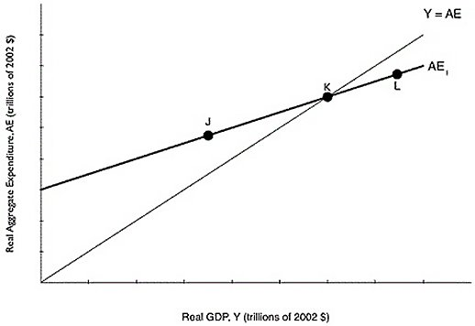

34) Refer to Figure 8.3. If the economy is at point J, what will happen?
A) Inventories have fallen below their desired level, so firms will decrease production.
B) Inventories have risen above their desired level, so firms will increase unplanned inventory investment.
C) Inventories have fallen below their desired level, so firms will increase production.
D) Inventories have fallen below their desired level, so firms will decrease unplanned inventory investment.
E) Inventories have risen above their desired level, so firms will decrease production.

35) If, in a closed economy, real GDP is $30 billion, consumption is $20 billion, and government purchases are $5 billion, what is total saving in the economy?
A) $5 billion
B) $15 billion
C) $25 billion
D) $45 billion
E) $55 billion

36) If the economy receives an influx of new workers from immigration,
A) we will move down along the long-run aggregate supply curve.
B) we will move up along the long-run aggregate supply curve.
C) the long-run aggregate supply curve will shift to the right.
D) the aggregate demand curve will shift to the left.
E) the long-run aggregate supply curve will shift to the left.

37) Which of the following explains why the unemployment rate tends to rise as a recession ends?
A) Firms reducing hiring as recessions come to an end.
B) Employment insurance tends to be more generous during recessions.
C) The federal government uses a different definition of "unemployed" during recession.
D) Discouraged workers begin to search for jobs.
E) The birth rate tends to rise during recessions.

38) An increase in net national income could be caused by which of the following?
A) an increase in housing costs
B) an increase in personal taxes
C) an increase in depreciation
D) a decrease in personal income
E) an increase in gross domestic product
Figure 9.3

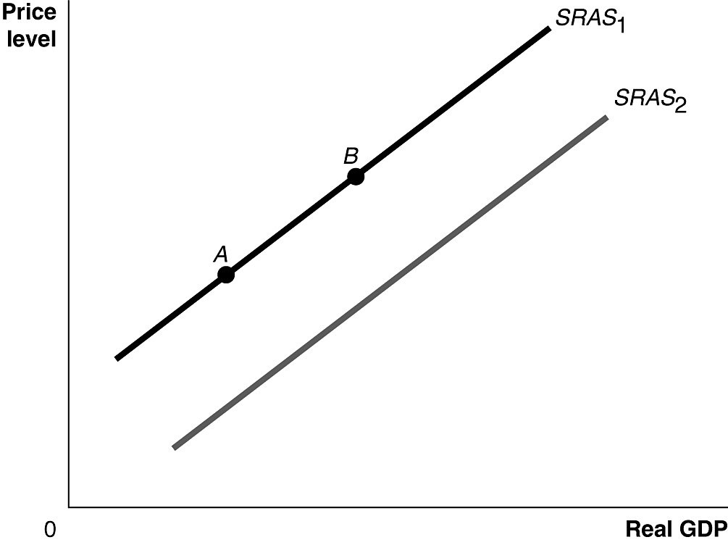

39) Refer to Figure 9.3. Ceteris paribus, an increase in the expected price of an important natural resource would be represented by a movement from
A) SRAS1 to SRAS2.
B) SRAS2 to SRAS1.
C) point A to point B.
D) point B to point A.
E) point 0 to point A.

40) Workers and firms both expect that prices will be 2.5% higher next year than they are this year. As a result
A) the short-run aggregate supply curve will shift to the left as wages increase.
B) long-run aggregate supply will shift to the right by 2.5%.
C) the purchasing power of wages will rise if wages increase by 2.5%.
D) aggregate demand will increase by 2.5%.
E) workers will be willing to take lower wages next year, but not lower than a 2.5 percent decrease.

41) Which of the following explains the changes in the Canadian adult male labour force participation rate since 1976?
A) There are fewer working age males than in the past.
B) More men are retiring later in life as compared to the past.
C) More men are joining the military as compared to the past.
D) Fewer men consider themselves discouraged workers as compared to the past.
E) Younger men are remaining in school longer as compared to the past.

42) If GDP is currently growing at 28 % a year, the velocity of money is growing at 1% a year, and the growth rate of money supply is 15%, what rate of inflation can this country expected based on the quantity theory of money?
A) -13%
B) 12%
C) 0.5%
D) -12%
E) 44%

43) When lumber from Brazilian forests is used by a U.S.-owned company to produce furniture in Canada, the value of the furniture produced will be counted as a final good in
A) U.S. GDP.
B) Brazil's GDP.
C) Brazil's GNP.
D) Canada's GDP.
E) Brazil's GNI.

Figure 7.3

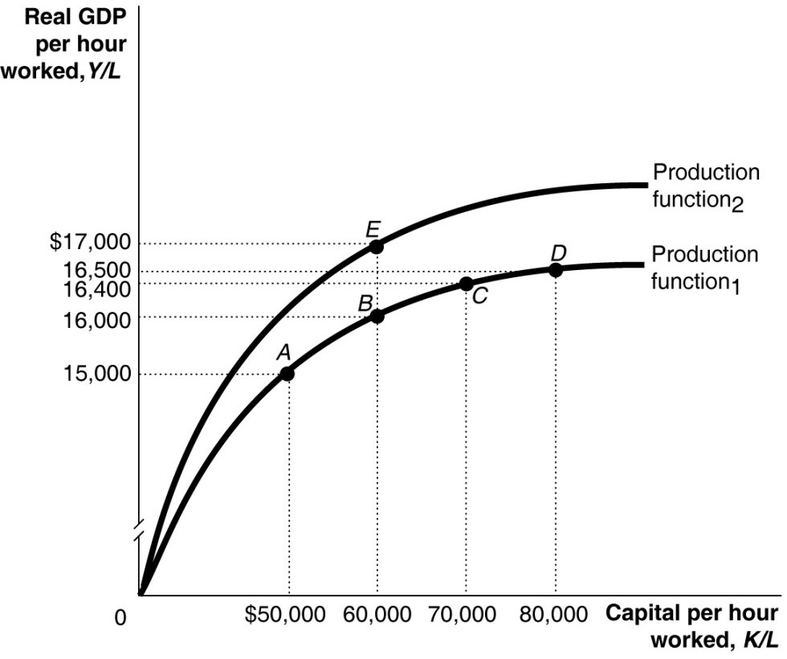

44) Refer to Figure 7.3. A large group of new workers entering the labour force is shown in the figure above by a movement from
A) A to B.
B) B to E.
C) C to B.
D) C to D.
E) E to B.

45) If real GDP in a closed economy is $40 billion, consumption is $20 billion, and government purchases are $10 billion, what is investment?
A) $10 billion
B) $30 billion
C) $40 billion
D) $55 billion
E) $70 billion

46) If real GDP grows by 7.0% in 2018, falls by 3% in 2019, and grows by 6% in 2020, what is the average annual growth rate of real GDP?
A) 1.4%
B) 2.9%
C) 3.3%
D) 4.2%
E) 5.3%

47) In a small economy in 2016, aggregate expenditure was $850 million while GDP that year was $800 million. Which of the following can explain the difference between aggregate expenditure and GDP that year?
A) Aggregate expenditure is always less than GDP in developed countries.
B) Aggregate expenditure does not account for consumer spending.
C) Firm investment in inventories was less than anticipated in 2016.
D) Firm investment in inventories was greater than anticipated in 2016.
E) Aggregate expenditure is always less than GDP in developing countries.

48) An increase in the purchasing power of money would not, on average, result in an increase in the purchasing power of people's income because a ________ price level would likely mean ________ wages and salaries.
A) rising; rising
B) falling; rising
C) falling; falling
D) falling; no changes in
E) rising; falling

49) Which of the following is an example of human capital?
A) a software program
B) a factory building
C) computers used by human resource departments
D) a computer
E) a university or college education

50) Which of the following would be a consequence of substitution bias in the CPI?
A) Economists make errors in estimating inflation when using substitutes for the CPI such as GDP deflator.
B) The inflation rate based on the CPI would underestimate the true level of inflation.
C) Businesses would overcompensate employees for inflation when giving the cost of living rises.
D) Social Security payments would not adequately compensate retired workers for inflation.
E) Judges would award child support payments that would not adequately keep up with the true cost of inflation.

51) Which of the following will cause a direct increase in consumption spending?
A) an increase in government spending
B) an increase in planned investment
C) a decrease in net export spending
D) an increase in disposable income
E) an increase in income taxes

52) Paul Romer, an economist at Stanford University, is most closely associated with what economic theory?
A) the quantity theory of money
B) the process of creative destruction
C) the Communist Manifesto
D) new growth theory
E) labour productivity theory

53) Which of the following tools of monetary policy is used least often?
A) purchase and resale agreements
B) setting the overnight interest rate
C) acting as a lender of last resort
D) sale and repurchase agreements
E) printing more money

54) Discouraged workers are classified by Statistics Canada as
A) unemployed.
B) part-time employees.
C) part of the labour force.
D) out of the labour force.
E) employed.

55) Active changes in tax and spending by government intended to smooth out the business cycle are called ________, and changes in taxes and spending that occur passively over the business cycle are called ________.
A) discretionary fiscal policy; automatic stabilizers
B) automatic stabilizers; monetary policy
C) active monetary policy; passive monetary policy
D) discretionary fiscal policy; conscious fiscal policy
E) automatic stabilizers; discretionary fiscal policy

56) An increase in aggregate demand in the economy will have what effect on macroeconomic equilibrium in the long run?
A) The price level will be unaffected and the level of GDP will rise.
B) The price level will rise and the level of GDP will be unaffected.
C) The price level will fall and the level of GDP will rise.
D) The price level will fall and the level of GDP will fall.
E) The price level will rise and the level of GDP will fall.

57) Suppose real GDP is $1.4 trillion and potential GDP is $1.9 trillion. To move the economy back to potential GDP, the federal government should
A) lower government purchases by $500 billion.
B) lower taxes by an amount less than $500 billion.
C) raise government purchases by more than $500 billion.
D) raise government purchases by $500 billion.
E) lower taxes by $500 billion.

58) If the government purchases multiplier equals 2, and real GDP is $1.7 trillion with potential real GDP of $1.75 trillion, then government purchases would need to increase by ________ to restore the economy to potential real GDP.
A) $1.75 trillion
B) $500 billion
C) $100 billion
D) $50 billion
E) $25 billion

59) Which of the following could explain why there is an increase in potential GDP but the equilibrium level of GDP does not rise?
A) AD shifted to the right by more than SRAS.
B) SRAS and AD do not shift.
C) The shift in LRAS was caused by a rise in investment.
D) SRAS shifted to the right by more than LRAS.
E) AD shifted to the right by less than SRAS.

60) Suppose the economy is at a short-run equilibrium GDP that lies below potential GDP. Which of the following will occur because of the automatic mechanism adjusting the economy back to potential GDP?
A) Aggregate demand will shift to the right.
B) Short-run aggregate supply will shift to the right.
C) Prices will increase.
D) Unemployment will rise.
E) Output will decrease.

61) Which of the following is most liquid?
A) a government bond
B) a corporate bond
C) a five dollar bill
D) a mutual fund share
E) a painting

62) Increases in real GDP since 1961 can actually underestimate growth in the standard of living for Canadians because
A) the crime rate was higher in 1961 than it is today.
B) the level of pollution in 1961 was much higher than it is today.
C) the quality of health care that exists today was not available in 1961.
D) fewer women participated in the paid labour force in 1961.
E) goods and services are more expensive today as compared to 1961.

63) If planned aggregate expenditure is greater than total production,
A) governments are likely to experience growing budget deficits.
B) the economy is in equilibrium.
C) GDP will increase.
D) actual inventories will equal planned inventories.
E) firms will experience an unplanned increase in inventories.

64) In a small Asian country, it is estimated that a $10,000 increase in capital per hour worked will increase real GDP per hour worked by $600. Based on this information, what is the slope of the per-worker production function in this range?
A) 0.0
B) 0.06
C) 0.6
D) 6.6
E) 66.6

65) There are no costs to inflation if it is fully anticipated.
A) True
B) False

66) A commercial bank like Bank of Montreal creates money by
A) selling corporate bonds.
B) making loans.
C) earning profits.
D) printing paper money.
E) distributing new currency printed by the Canadian mint.

67) Poorly timed discretionary policy can do more harm than good. Getting the timing right with fiscal policy is generally
A) impossible due to the interference from the Bank of Canada.
B) far less difficult than with monetary policy.
C) about the same difficulty as with monetary policy.
D) less difficult than with monetary policy.
E) more difficult than with monetary policy.

68) When U.S. GDP grows more slowly compared to Canada,
A) government spending in Canada will likely decrease.
B) Canadian prices will rise more quickly causing household disposable income to fall in Canada.
C) Canadian firms will invest more, causing domestic investment to rise and Canadian GDP to fall.
D) Canadians will export some of the newly made Canadian goods, causing U.S. GDP to shrink.
E) Canadian firms will export less, leading to slower Canadian GDP growth.

69) If the nominal interest rate is 6% and the inflation rate is 9%, then the real interest rate is
A) -3%.
B) 3%.
C) 6.67%.
D) 15%.
E) 25%.

Table 5.15
Year | Nominal Average  Hourly Earnings | CPI
2017 | $15 | 100
2018 | 15 | 105
2019 | 18 | 110

70) Refer to Table 5.15. Looking at the table above, real average hourly earnings were equal to ________ in 2018.
A) $13.63
B) $14.29
C) $15.00
D) $16.50
E) $18.36

71) Which of the following causes the unemployment rate to understate the true extent of joblessness?
A) Persons who collect unemployment benefits report themselves to be searching for a job.
B) A drug dealer reports herself as unemployed.
C) Some people do not want to have a paid job.
D) Many full-time workers really want to be part-time workers.
E) Discouraged workers are not counted as unemployed.

72) Caroline is an artist. She purchases canvas, paints, brushes, and accessories for $75. She sells one of her original paintings to an art gallery for $1,500. The gallery, in turn, sells the painting to an art lover for $4,500. How much value does the gallery add?
A) $1,425
B) $1,500
C) $3,000
D) $4,500
E) $5,075

73) Most economists believe that the return of ________ during the 2008-2009 recession is a key reason why the recession was so severe.
A) high unemployment
B) financial instability
C) high interest rates
D) high tariffs
E) rapid inflation

74) Which of the following best describes the "wealth effect"?
A) When the price level falls, the real value of household wealth falls.
B) When the price level falls, the nominal value of household wealth falls.
C) When the price level falls, the nominal value of household wealth rises.
D) When the price level falls, the real value of household wealth rises.
E) When the price level falls, the value of stocks rise.

75) The Bank of Canada maintains an operating band for the overnight interest rate of
A) 50 percent of the inflation rate.
B) 50 basis points below the bank rate.
C) 50 percent of the bank rate.
D) 50 basis points below the inflation rate.
E) 50 basis points above the prime rate.

76) The per-worker production function has a ________ slope, indicating that increases in capital per hour worked ________ real GDP.
A) negative; increase
B) negative; decrease
C) positive; decrease
D) positive; increase
E) vertical; decrease

77) An increase in ________ shifts the production function ________, and makes it possible to produce a higher level of GDP with ________ capital per hour worked.
A) technology; down; the same amount of
B) technology; up; the same amount of
C) labour productivity; down; the same amount of
D) consumption; up; a lesser amount
E) capital stock; up; a lesser amount

78) If nominal GDP exceeds real GDP for a specific year, then the GDP deflator must be
A) less than 0.
B) equal to 100.
C) equal to its value in the base year.
D) less than 100.
E) greater than 100.

79) Which of the following is considered a negative supply shock?
A) an unexpected increase in the price of natural gas
B) a drop in investment spending
C) increasing investment in the economy causes the capital stock to rise
D) a decline in wages
E) an improvement in technology

80) Which of the following is not counted in M1+?
A) coins in circulation
B) non-chequable deposits
C) credit card balances
D) currency in circulation
E) chequing account balances

